Design of a Book Classification and an Efficient Access Device Embedded in a Sofa

Jinwu LUO, Zhongqi XU, Daquan TONG, Chao WU

School of Intelligent Manufacturing

Chengdu Technological University

Chengdu, China

ljwcdtu@163.com

**Abstract—With the increasing interest in reading, traditional bookshelves require manual sorting and classification of books, which is very inconvenient for families with large collections who enjoy reading. This project aims to develop a fully automated book storage device that integrates recognition, classification, and storage. The main controller uses an STM32 microcontroller, which manages USART (Universal Synchronous/Asynchronous Receiver/Transmitter) serial communication for data exchange between the controller, barcode camera, and voice module. Stepper motors drive mechanical movement along the Y/Z axes, while a high-precision encoder motor handles the X-axis for book storage. The device allows precise retrieval of books through voice commands. This innovative storage solution combines a sofa and bookcase with built-in bookshelves for easy storage and access. Intelligent sensing technology adjusts book arrangement dynamically based on user preferences. The system greatly reduces physical storage space while improving the experience of reading during fragmented free time.**

Keywords：book classification; intelligent access; structural design; STM32

# Introduction

As people's living standards and cultural literacy improve, interest in reading has steadily increased, leading to more book collections in households. According to the results of the 20th National Reading Survey released by the Chinese Academy of Press and Publication in 2022 [1] :

(1) The comprehensive reading rate among Chinese adults reached 81.8%, marking a 0.2 percentage-point increase from 2021.

(2) The adult book reading rate stood at 59.8%, with an average of 4.78 paper books, 14.76 newspapers, and 1.88 periodicals read per capita.

(3) Among juveniles (0–17 years), the reading rate was 84.2%, with an average of 11.14 books read per capita.

(4) Notably, 45.5% of adults expressed a preference for physical books.

Family reading serves not only as a means for knowledge acquisition and cognitive enhancement but also as a vital channel for communication and interaction among family members and society [2].

This not only broadens children's knowledge but also strengthens parent-child relationships, particularly crucial for children's physical and mental development [3].

However, the increasing number of books per household presents challenges related to storage, access, and classification. Disparities in urban-rural development have led to uneven allocation of public reading resources and significant gaps in infrastructure, exacerbating issues in family reading resource allocation [4]. To address these challenges, the concept of an intelligent sofa bookcase emerged. This device utilizes an STM32 microcontroller as its core controller. Communication with a barcode scanner and voice module is accomplished via USART serial communication. Stepper motors drive mechanical movement along the Y and Z axes, while high-precision encoder motors drive the X-axis for book storage. Book retrieval is accomplished accurately through voice commands.

# Device Design

## Structural and Functional Analysis

The Sofa-Embedded Book Sorting and Efficient Access Device is an innovative storage unit integrating sofa and bookcase functionalities. It combines comfortable seating with dedicated storage space for books, facilitating reading in comfort. The design incorporates built-in bookshelves for easy storage and access. Intelligent sensing technology adjusts the book layout based on user preferences and reading needs, optimizing the reading experience. By combining smart storage technology with the sofa structure, this device minimizes the physical space required for book storage in homes while providing a comfortable reading environment. Features such as automated organization, sorting, and labeling contribute to maintaining an orderly and easily searchable collection, enhancing both the reading experience and space utilization efficiency. This creates a functional and appealing reading environment that fosters a passion for reading.

## Working Principle

Books are inserted into the book insertion slot of the sofa bookcase. They slide onto the book transfer platform via rails, triggering a photosensitive sensor that detects their arrival. The workflow (Fig. 1) is as follows:

Scanning: A camera scans the book's barcode.

Measurement: A laser distance measuring module determines the book's dimensions (length, width, height) and calculates its volume.

Classification & Matching: Book information retrieved from the barcode is used for classification. Bookshelf compartments are then matched based on the book's size.

Positioning & Storage: The transfer platform moves to the designated compartment location (using Y/Z stepper motors and X-axis encoder motor). An encoder motor rotates a lead screw, driving a pusher to insert the book into the compartment.

Recording: The STM32 master control records the book's position in Flash memory for future retrieval.

This process enables automatic recognition, recording, sorting, and storage. Book retrieval is controlled via voice commands. The mechanical system is depicted in Fig. 2.

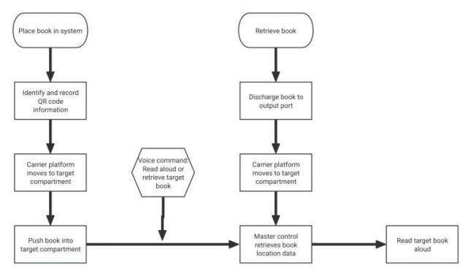

1. *Device Workflow Diagram*

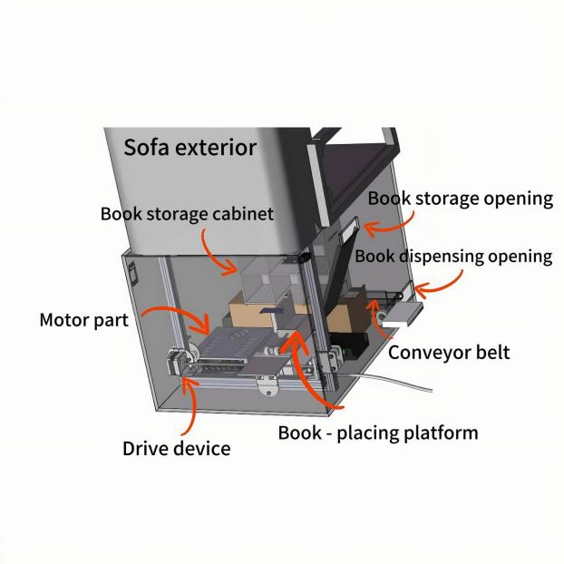

1. *Access Device System*

# Component Design

To maximize the utilization of limited home space, the book device is integrated into the base of the sofa. This design efficiently repurposes underutilized space and provides convenient book access. The main device appearance is shown in Fig. 3.

|  |  |
| --- | --- |
| **屏幕截图 2023-10-20 212220** | **屏幕截图 2023-10-20 212109** |
| **（a）Front view** | **(b)Side view** |

1. *Main Unit Appearance*

The device comprises three main subsystems: mechanical structure, control system, and sensing system.

## Mechanical Structure

The mechanical structure primarily consists of: a mobile platform, a lifting device, a conveyor belt, and a bookshelf. Transmission is achieved via synchronous belt drives. A synchronous belt drive consists of a driving pulley, a driven pulley, and the toothed belt connecting them. Transmission relies on the meshing of the belt teeth and pulley teeth, resulting in no relative slip and high transmission efficiency [5].

Mobile Platform (Fig. 4): Two vertical slide rails are fixed inside the sofa frame. Stepper motors adjacent to each vertical rail drive lead screws, enabling precise vertical movement of the book transfer platform. Two stepper motors at each end of a horizontal track drive an internal belt connected to the platform, enabling precise horizontal movement. This design allows the 3-axis planar movement of the transfer platform. To store a book, the platform moves it to the designated compartment, where a pusher (driven by a stepper motor via a lead screw) inserts the book. Retrieval involves positioning the platform at the compartment and using the pusher to eject the book onto the conveyor belt.

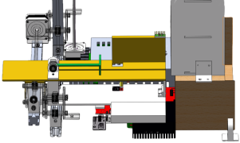

1. *Mobile Platform*

Lifting Device (Fig. 5): Primarily responsible for Z-axis movement, this device uses a stepper motor and lead screw to raise and lower the transfer platform or associated components for precise positioning relative to the multi-layer bookshelf compartments.

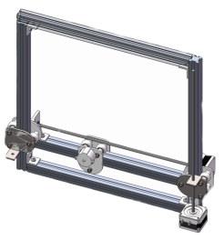

1. *Lifting Mechanism*

Conveyor Belt (Fig. 6): Upon being ejected from a compartment, the book falls onto a conveyor belt. A laser sensor detects the book, triggering the belt motor. The belt transports the book to the transfer platform for final presentation at the retrieval slot.

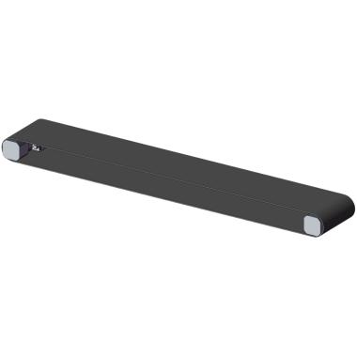

1. *Conveyor Belt*

Bookshelf (Fig. 7): Employs a three-dimensional warehouse design for optimal space utilization [6]. It contains compartments of various sizes, each capable of storing a book within its specific volume range. The moving platform, lifting device, and laser distance measurement work in concert to store books of differing sizes effectively.

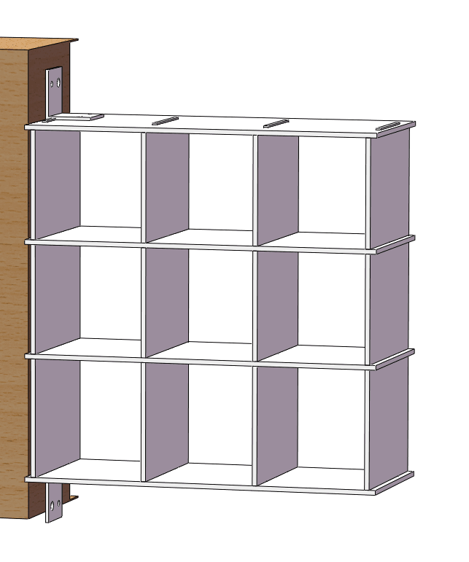

1. *Bookshelf Structure*

## Control System

The control system (Fig. 8) primarily comprises: STM32F411CEU6 microcontroller, switching power supply, stepper motor drivers, buck converter module, motor driver modules, and associated circuitry.

Storage Process: After book classification and compartment targeting, the encoder motor drives the pusher screw to insert the book.

Retrieval Process: After voice command and book location lookup, the platform positions itself at the compartment. The pusher ejects the book onto the conveyor belt. The photosensor detects the book, activating the conveyor belt motor to transport it to the transfer platform. The lifting device then raises the platform to present the book at the retrieval slot.

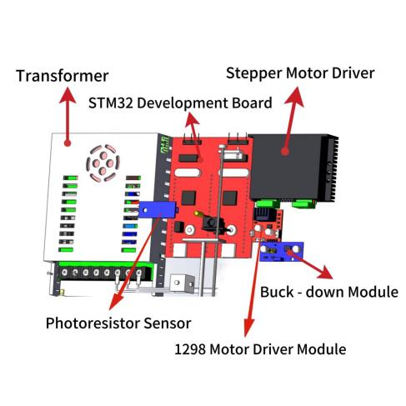

1. *Device Control System*

## Sensing System

The sensing system includes a barcode reading module, a laser distance measuring module, photosensitive modules, and laser modules.

Barcode Reading Module: Scans the ISBN barcode or QR code on the book cover upon insertion. This data, combined with dimensional measurements, is archived by the controller for future retrieval.

Laser Distance Measuring Module: Measures the book's length, width, and height as it rests on the transfer platform after insertion. This data is critical for volume calculation, classification, and determining a suitable storage compartment.

Photosensitive Modules: Detect the presence of a book at key points (e.g., on the insertion slide, transfer platform, conveyor belt).

Laser Modules: Used for precise positioning or triggering events (e.g., detecting a book on the conveyor belt).

# Prototype Development

## Prototype Fabrication

Following motion simulation to verify the feasibility and rationality of the design, a functional prototype was assembled—the frame and lifting structure utilized aluminum alloy profiles. The bookshelf was constructed from transparent acrylic sheets. The upper seating surface was upholstered with cotton fabric to form the sofa, while other external parts were made of plastic materials. The prototype is shown in Figures 9, 10, 11, and 12.

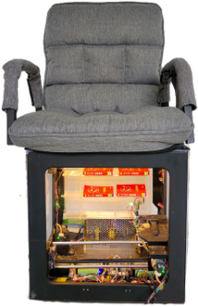

1. *Physical Prototype Front View*

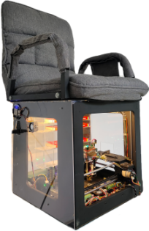

1. *Physical Prototype Right-side View*

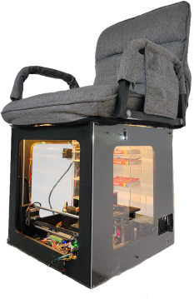

1. *Physical Prototype Left-side View*

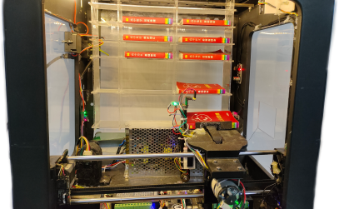

1. *Physical Prototype Internal Structure*

## Prototype Testing

Device functionality was tested in an indoor environment. After powering the prototype:

Retrieval Test: Upon receiving a book retrieval command via voice or APP, the device efficiently retrieved the target book. The retrieval process flowchart is shown in Fig. 13.

Storage Test: Inserting a book into the slot triggered identification via its barcode. The device then classified the book and stored it appropriately on the bookshelf. The storage process flowchart is shown in Fig. 14.

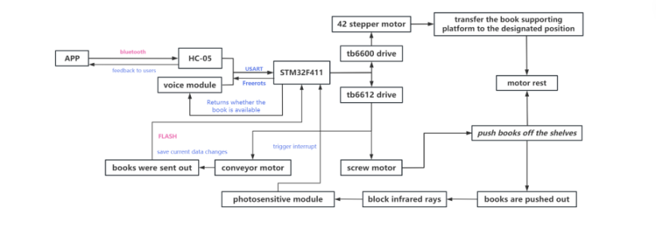

1. *Book Retrieval Workflow*

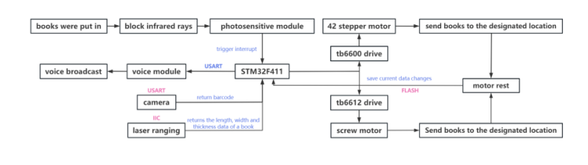

1. *Book Storage Workflow*

Fig. 15 illustrates the device storing books. Fig. 16 illustrates the device retrieving books. Test results (TABLE I, II) demonstrated that the book storage and retrieval functions were largely consistent with design expectations, indicating that the device's structural and program design are reasonable and meet functional requirements.

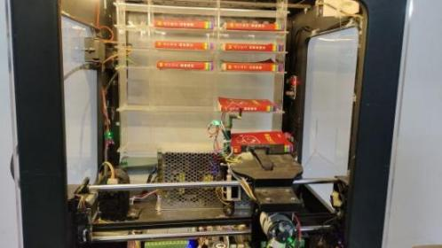

**(a)**

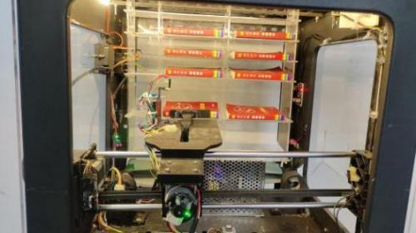

**(b)**

1. *Device Book Storage Process*

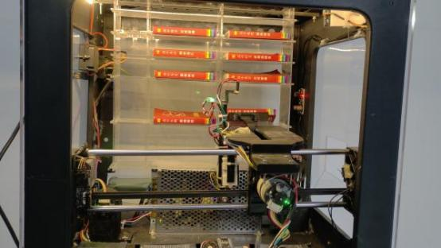

**(a)**

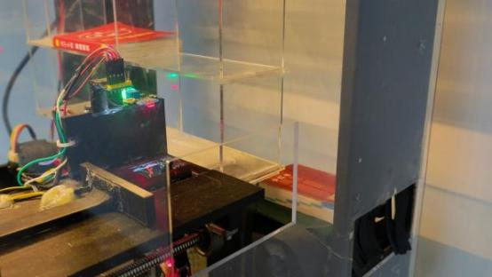

**(b)**

1. *Device Book Retrieval Process*
2. Book Access Performance Test Data

| **Test Item** | **Average** | **Maximum** | **Minimum** |
| --- | --- | --- | --- |
| Single book storage time | .s | .s | .s |
| Single book retrieval time | .s | .s | .s |
| Barcode recognition accuracy | .% | % | .% |
| Volume measurement error | ±.mm | ±.mm | ±.mm |
| Positioning repeatability (X-axis) | ±.mm | ±.mm | ±.mm |

1. Dynamic Load Testing

| **Load Mass (g)** | **Access Time (s)** | **X-axis Positioning Error (mm)** | **Power Consumption (W)** |
| --- | --- | --- | --- |
|  (single book) | .±. | .±. | . |
|  (heavy book) | .±. | .±. | . |
|  (max load) | .±. | .±. | . |

## Prototype Hardware Configuration

The hardware of the physical prototype (Fig. 17) primarily consists of:

Control: STM32F411 microcontroller, HC-05 Bluetooth module.

Sensing: Barcode camera module, laser distance measurement module, photosensitive modules, laser modules, temperature sensor module.

Actuation: 42 Stepper motors (for Y/Z axes, pushers, lift), high-precision encoder motors (for X-axis), conveyor belt motors.

Drivers: TB6612 motor driver modules, TB6600 stepper motor controllers.

Power: Switching power supply, 24V backup battery, buck converter module.

Logic: Supporting circuitry.

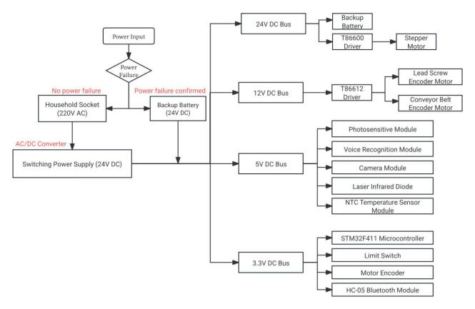

1. *Hardware Configuration Diagram*

Power is normally supplied via a transformer connected to the household mains. A 24V backup battery powers the device during main outages. When mains power is restored, the system automatically switches back and charges the backup battery, stopping at a preset charge level. This ensures the continuous operation of the embedded book sorting and access device.

# Extended Application

Following the successful prototype experiment, a multi-person sofa bookcase was designed based on the core technology. The fundamental operating principle remains unchanged:

Book insertion via slot onto the transfer platform.

Book recognition (barcode scan) and dimension measurement (laser).

Classification and compartment matching.

Precise platform positioning (stepper motors for Y/Z, encoder for X).

Pusher-driven storage (encoder motor).

Voice-commanded retrieval: Pusher ejects the book onto the conveyor belt.

A conveyor belt transports the book to the transfer platform upon detection (photosensor).

The platform lifts the book to the retrieval slot.

Key differences from the principal prototype are:

Increased Capacity: The internal bookshelf structure is enlarged to accommodate nearly 300 books, meeting the needs of most families.

Multi-Seat Design: Incorporates more seating positions to accommodate multiple users simultaneously, catering to larger families. This further optimizes space utilization by combining seating and substantial book storage.

Internet Connectivity: Enables features such as online audiobook playback, creating a more versatile and engaging reading environment.

The basic appearance and internal structure of the multi-person sofa bookcase are shown in Figures 18 and 19. TABLE III shows the space utilization between the traditional bookshelf, single-person sofa unit, and multi-person sofa bookcase.

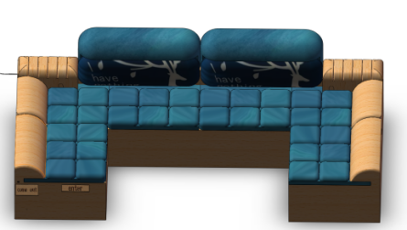

1. *Multi-user Sofa Basic Appearance*

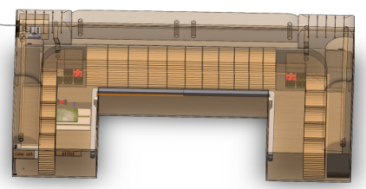

1. *Multi-user Sofa Internal Structure*
2. Space Utilization Comparison

| **Storage Solution** | **Capacity (books)** | **Floor Area (m²)** | **Space Utilization (%)** |
| --- | --- | --- | --- |
| Traditional bookshelf |  | . | % |
| Single-person sofa unit |  | . (sofa base) | % |
| Multi-person sofa bookcase |  | . | % |

# Conclusion

The Intelligent Sofa Bookcase presents an innovative storage solution that seamlessly integrates sofa functionality with intelligent book storage. Its unique design incorporates built-in bookshelves for effortless storage and retrieval, combined with comfortable seating to provide a cozy reading environment that enhances the reading experience and fosters a passion for reading. By leveraging smart storage technology embedded within the structure of a traditional sofa, this device enables households to significantly reduce the space dedicated to conventional bookshelves while efficiently utilizing the often-wasted space inside sofas. It offers reading enthusiasts a comfortable experience alongside efficient space utilization, creating a practical and appealing reading space. This device enhances home functionality and intelligence while optimizing valuable living space.

### References

[1] Institution of National Library of China, "Results of the 20th National Reading Survey," National Library Journal, vol. 32, p. 103, 2023.

[2] J. S. H. Jiang, "Strengthening Family Reading Education: Laying the Foundation for Children's Lifelong Learning Power," New Reading, vol. 05, pp. 21-22, 2020.

[3] S. S. Mo, "Exploring the Role of Parent-Child Reading in Family Education," Happy Reading, vol. 13, p. 17, 2013.

[4] Z. Wang and Z. Q. Qin, "Family Reading Education: Current Situation, Influencing Factors and Practical Path," New Reading, vol. 09, pp. 67-70, 2023.

[5] H. Zheng, "Synchronous Belt Drive Characteristics and Control of Synchronous Wheel Design and Manufacture," Internal Combustion Engines and Accessories, vol. 09, pp. 121-123, 2018.

[6] C. S. Zhang, D. C. Cai, and Y. J. Cao, "Design of Intelligent Storage System Based on STM32," Automation Technology and Application, vol. 40, pp. 31-34, 2021.