Study of the digitalization in the universities, using mobiles aplications.

Ing. Víctor Figueroa Chávez¹.

University of Guanajuato, Campus Irapuato-Salamanca 36685, Department of Multidisciplinary Studies, Yuriria Guanajuato, México

v.figueroachavez@ugto.mx

Dr. Geovanni Hernández Gómez²
Dr. Eduardo Cabal Yépez²
University of Guanajuato, Campus Irapuato-Salamanca 36685, Department of Multidisciplinary Studies, Yuriria Guanajuato, México.

geov.hernandez@ugto.mx
educabal@ugto.mx

Abstract—This study addresses digitalization in the education sector, examining how it has provided a crucial impetus for modernizing essential activities within schools and universities. We explore how the integration of digital technologies enhances administrative and academic processes and transforms the student learning experience through the incorporation of virtual environments, interactive platforms, and digital resources. With this background, we have developed multiple applications aimed at achieving these benefits by facilitating interactions between students and teachers, as well as improving access to educational services and content. Subsequently, we compare traditional processes with digital ones to determine if digitalization offers greater advantages over traditional methods and assess the necessity of digitalizing these processes.

Introduction
The digital transformation of the world has accelerated the adoption of digital technologies across multiples sectors, with one of the most impacted being education. This adoption has resulted in higher quality, more competitive services that are also environmentally sustainable. Digital transformation primarily benefits secondary schools, high schools, and universities, this means the schools are required to integrate the latest technologies into their operations and interactions with students to enhance competitiveness.

To effectively leverage desktop applications, mobile applications, process digitalization, and method optimization, among other technologies, it is essential for academic institutions to modernize their processes and compare digital methods with traditional and analog methods.

Given this context, some applications were developed to simplify processes such as registering attendees at local university events through mobile applications and cloud storage, recording evidence for accreditation bodies via desktop applications, and managing classroom attendance records.

state of the art review

Digitalization in the education sector is a continuously expanding phenomenon driven by the need to enhance educational and administrative processes using new technologies. Notably, mobile applications and facial recognition technology significantly improve educational management, enhance teacher-student interactions, and enable effective control of student attendance.

Ramírez (2021) emphasizes in his study [1] that digital transformation in universities during the COVID-19 pandemic involved integrating new technologies and modifying educational models. He highlights machine learning, artificial intelligence, and adaptive leadership as key elements. Similarly, Santos et al. (2022) [2] document how digital platforms such as Massive Open Online Courses (MOOCs) alter teachers' roles and institutional strategies, facilitating access to more affordable and scalable courses, yet requiring new digital competencies from faculty.

Gómez-García et al. (2022) [3] also recognize that the pandemic exposed technological shortcomings; however, they conclude that digital transformation is essential because it enhances educational quality and fosters innovative learning. Likewise, Paz Prendes (2022) [4] emphasizes that universities must reinvent themselves based on three pillars: addressing student needs, faculty training, and institutional leadership. Innovation with new technologies necessitates new pedagogical methods that leverage these technologies effectively.

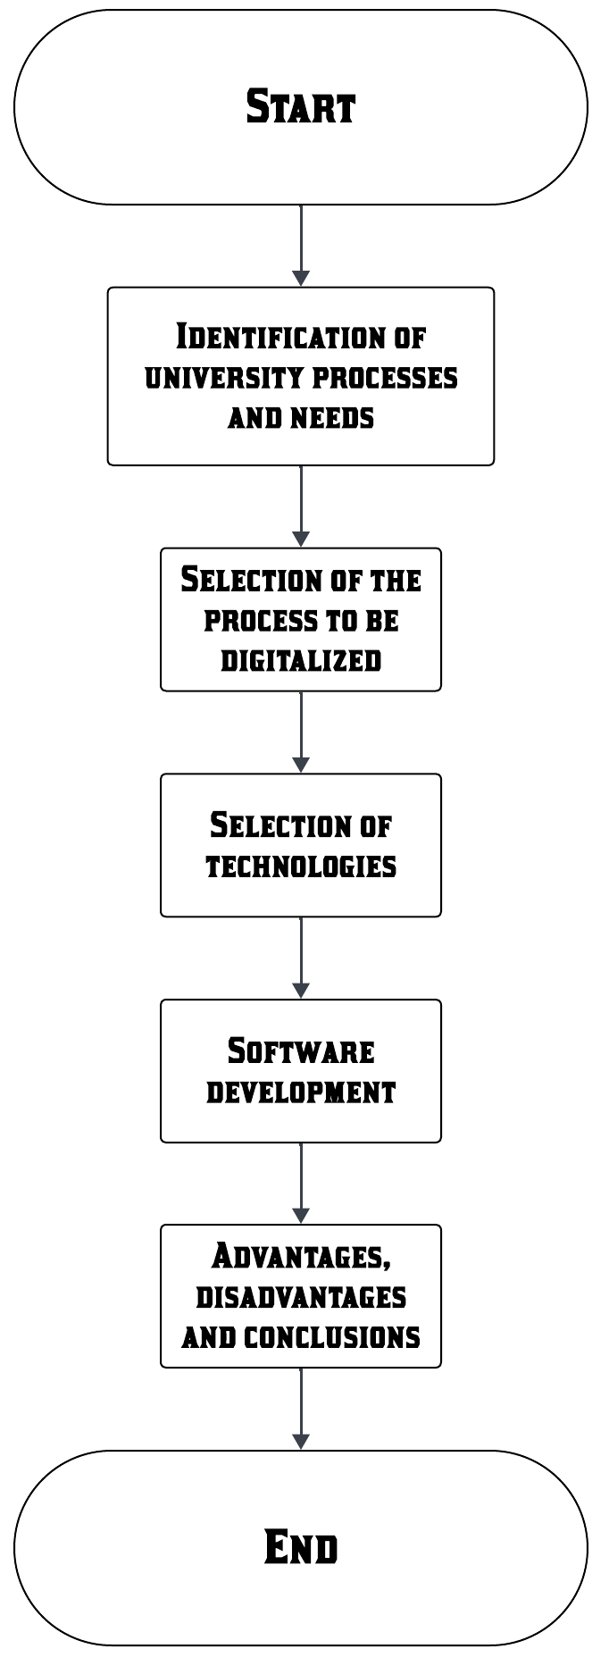
Camizan et al. (2025) [5] note that pedagogical innovation significantly strengthens teaching, educational equity, and the effective integration of emerging technologies like artificial intelligence in higher education. Petrusevich (2020) [6] also agrees that educational digitalization, notably accelerated by the pandemic, has reinforced the use of educational technologies, underscoring the importance of continuous evaluation to ensure effectiveness and sustainability.

Facial recognition technologies for managing student attendance have been extensively tested. Salvatierra Tumbaco (2018) [7] developed a system for "Julia Navarrete Mendoza" Educational Unit using Amazon Rekognition, validated through usability tests, demonstrating effective management of mass attendance.

Pierre Olivier et al. (2022) [8] describe an integrated platform developed with Microsoft Power Apps and Teams in Canadian educational institutions, demonstrating technical feasibility and simplified educational management through digital tools that allow personalization and scalability via mobile, or web applications provided by Microsoft services.

Furthermore, Ivett Vilchis-Torres (2025) [9] explores the evolution and current state of university digitalization in Spain and Mexico, highlighting that Mexican universities experience varied digitalization due to greater autonomy, while Spain progresses uniformly supported by national backing and the European structure. Similarly, Ramírez-Díaz (2024) [10] analyzes digitalization structures, regulations, and operations, identifying significant differences, noting that Spain benefits from a robust European Union framework guiding and funding this transformation, whereas Mexico lacks such a framework, leading to inconsistent and discontinuous plans.

Educational digitalization, enhanced by mobile applications and advanced technologies such as facial recognition, demonstrates clear benefits in administrative efficiency, student engagement, and school management. These advancements should be accompanied by strategic planning, teacher training, and regulatory frameworks to ensure the effective implementation of these technologies.

methodolgy
In "Flowchart 1," the steps for process digitalization within the test university are shown.
Given the demands of the student community and the education sector, research identified that events held at various campuses of a local university in Guanajuato, Mexico, require evidence collection for students to earn extracurricular credits and for organizing faculty members to document their essential activities. Traditionally, this process involves physical attendance sheets provided during each activity.

Flowchart 1: Process selection.

This traditional method poses logistical complications, risks of information loss, illegible information, and difficulties with subsequent tracking. Recognizing these issues, a decision was made to develop a mobile application to completely replace physical sheets, digitalizing the process of registering and managing evidence. The development of this application aims to improve information control and storage, provide immediate access to evidence, and enhance data security, benefiting students, professors, and administrators.

For technology selection, mobile applications and database systems were chosen. Since the university possesses Microsoft licenses, PowerApps was used to develop mobile applications, and SharePoint was selected for data storage.

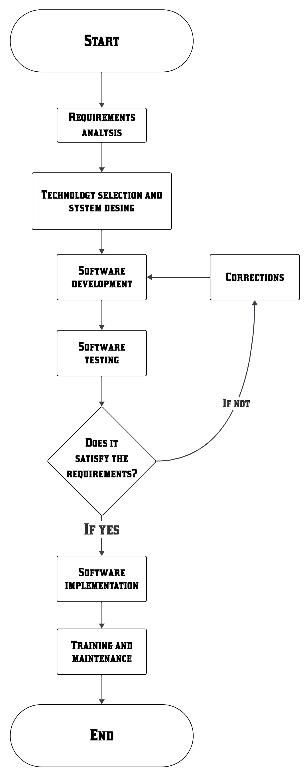
After choosing the technologies to digitalize the selected process, "Flowchart 2" illustrates the steps involved in software development.
Flowchart 2: Software Development.

• The first step in digitalizing the various processes investigated involves understanding current operational procedures to identify the requirements our digital applications must meet.
• Once the requirements are identified, the software application is designed, and suitable technologies are selected to satisfactorily overcome identified challenges.
• Subsequently, the applications are developed across their respective environments.
• After developing a functional prototype, it is tested to ensure it meets the established requirements.
• If the prototype has issues or fails to meet requirements satisfactorily, the software is redesigned and tested again.
• Once our software meets the proposed requirements, staff training is conducted for proper utilization and maintenance.

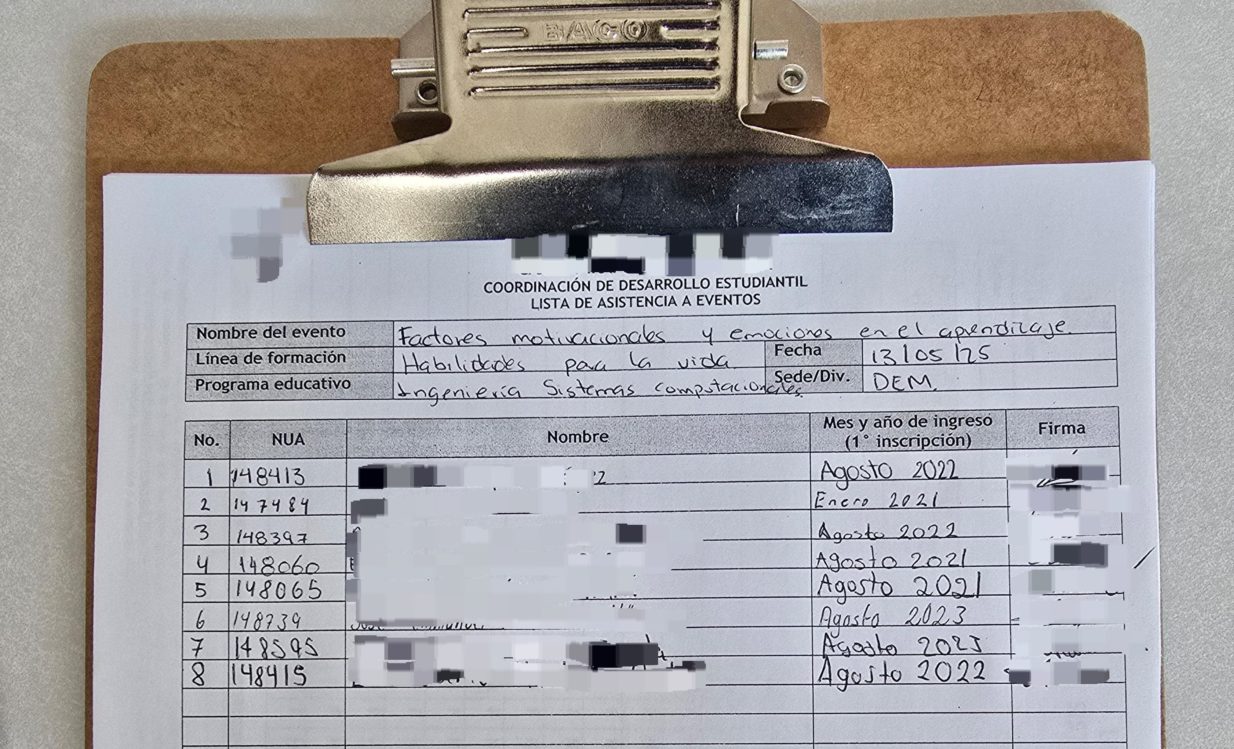
The traditional process begins when a faculty member organizes a congress, conference, or workshop, providing registration sheets at event entrances as evidence of assigned activities. "Figure 1" illustrates a list representing the current process.
Figure 1: Attendance List for Events at the Test University.

In "Figure 1," we observe all the parameters required for students to register attendance at an activity: their unique student number, full name, initial enrollment, and signature.

Based on these parameters, a database was created in SharePoint’s cloud service as a list. This list successfully replicates physical registration sheets, including all required data and additional important details.
Figure 2: Header of the SharePoint List.

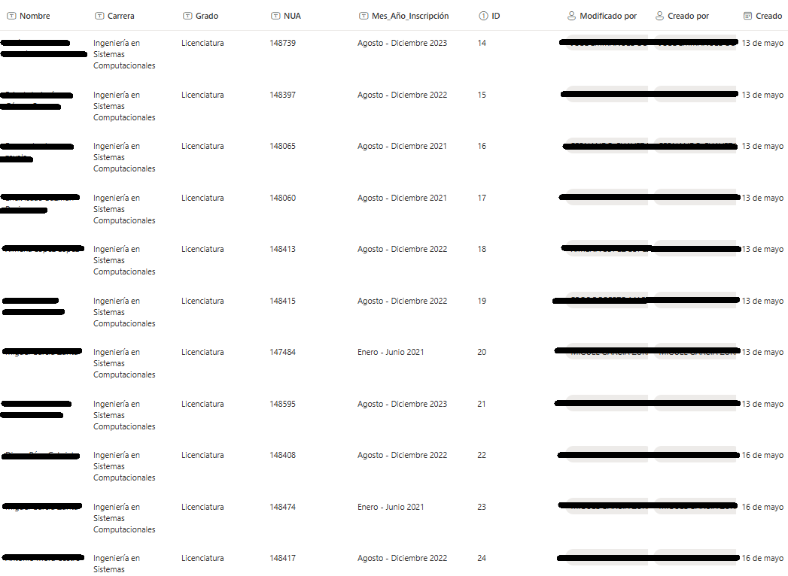
In "Figure 2," the list includes fields such as Name (Nombre), Major (Carrera), Grade (Grado), unique student number (NUA), enrollment month and year (Mes año de inscripción), ID (automatically generated internal parameter), Modified By (Modificado por), Created By (Creado por), and Created date (Creado).

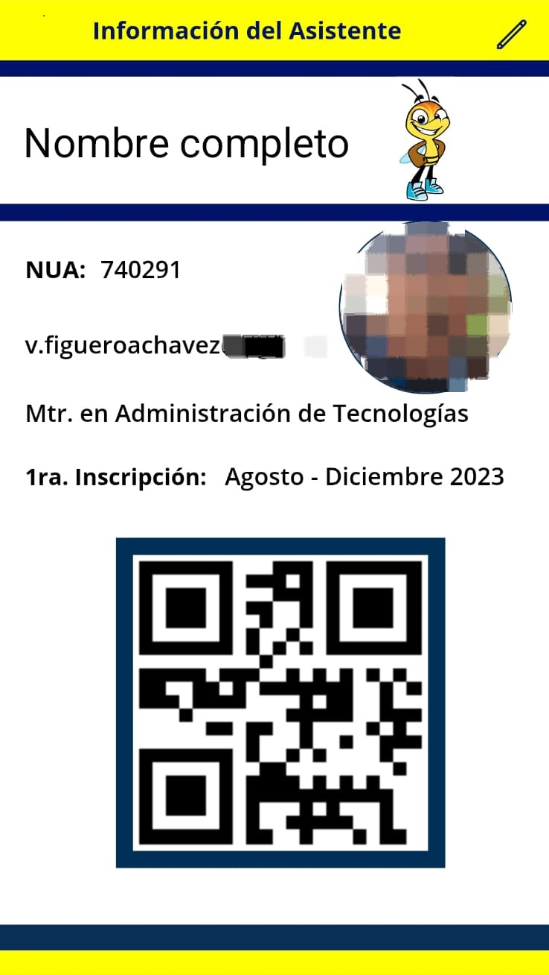
To digitalize this data, a mobile application was developed for attending students. This app allows students to enter their data into the database. After registering their information, students receive a QR code used to register attendance at events, conferences, or workshops. "Figure 3" shows a screen from the student application.
Figure 3: Mobile Application for Attending Students.

In "Figure 3," we see students digitalizing required data from physical sheets, such as full name, unique student number, and initial enrollment, along with additional details like institutional email and their major. A crucial parameter from physical sheets—the student's "signature"—is absent. To address this, students log in using their institutional email, thus authenticating their session and fulfilling the "signature" requirement.

Once students have access to the mobile app and digitalize their data, a list of registered students is generated in the database.
Figure 4: Digitalization of Attending Students' Data.

In "Figure 4," we see how data required on physical sheets are successfully replicated and digitalized in the SharePoint cloud list.

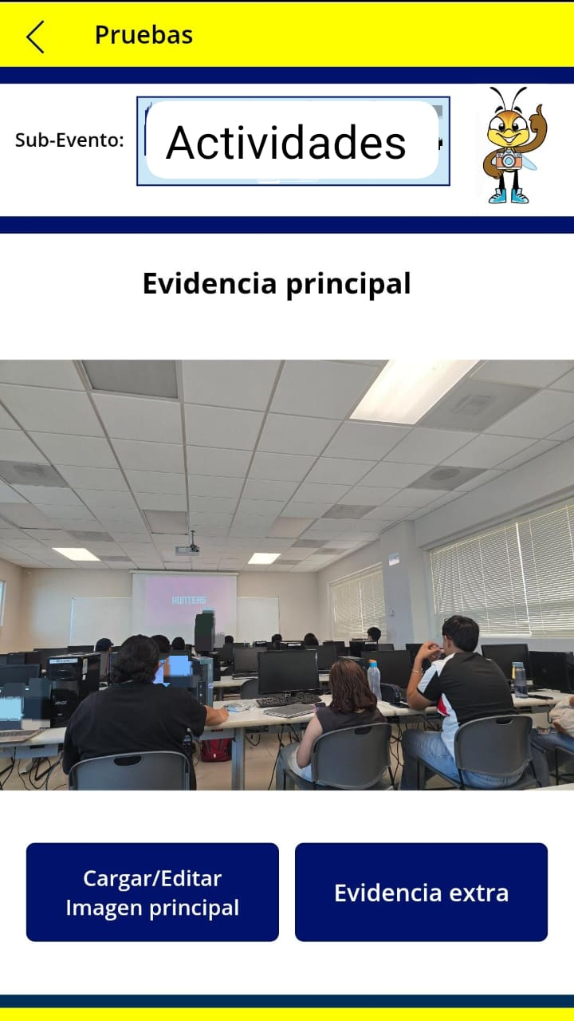
Next, a mobile application was developed for event organizers, allowing users to create events, activities, and attendee lists. The application includes various functions, such as uploading multimedia evidence linked to specific events, viewing real-time student registrations, and generating PDF lists of event evidence.
Figure 5: Application for organizers.
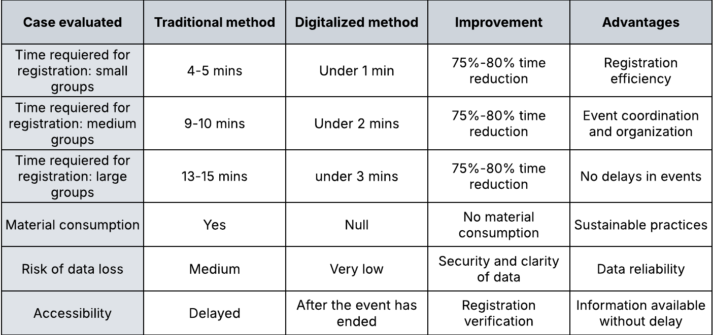
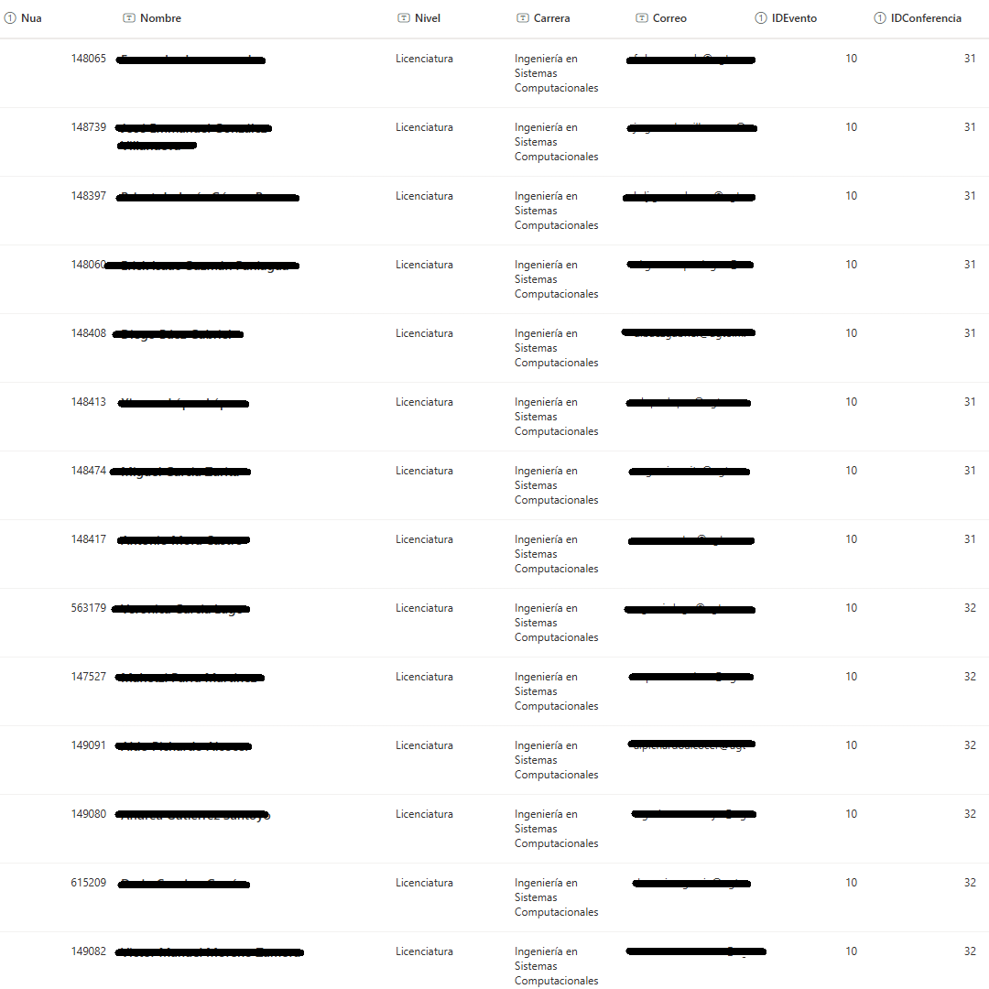
"Figure 5" provides an example of multimedia evidence stored in the database, identified by event and sub-event names. Besides “Main Evidence," it supports four additional multimedia pieces and uploading PDF attendance lists.

Figure 6: Digitalized Attendance List.

“Figure 6” demonstrates a successfully generated digital list created by scanning attendee QR codes during university events, ensuring all necessary student data for attendance verification are correctly stored in the database.

conclusions

In the following table, “Table 1,” we observe cases where our digital registration and cloud storage system was tested. The system was implemented at various events within the university, including small groups (14 to 18 people), medium groups (19 to 32 people), and large groups (over 32 attendees). Typically, these events experience delays in registration due to factors such as slow registration speeds, insufficient kiosks, large crowds, and other unexpected issues. The application aims to resolve these challenges by streamlining and organizing event registration. Additional benefits of digitalization include the absence of natural resource consumption, reduced risk of data loss by addressing issues related to handwriting legibility, and improved data availability.

Table 1: Comparation of digitalization and traditional.

In "Table 1," we can see the various advantages offered by the digitalization of a selected process at the test university. Registration time was reduced by 75% to 80%, providing benefits such as better event coordination, increased orderliness, prevention of delays, and enhanced registration efficiency. Furthermore, this digitalization offers greater data security, remote access to information stored in the cloud, and the avoidance of natural resource consumption.

This digital ecosystem aligns with the everyday dynamics of newer generations, increasing student interest and participation, and fostering deeper engagement with their academic training. Thus, digitalization at universities using mobile applications and other technologies becomes a strategic element to attract, retain, and motivate students.

These digital transformations also significantly improve administrative efficiency and educational management. This modernization process transforms how universities interact with their students, enhancing these interactions and responding effectively to an increasingly interconnected technological society.

References

[1] Ramírez, M. R. (2021). Transformación digital en las Universidades: Proceso en épocas de COVID 19. Revista Ibérica de Sistemas e Tecnologias de Informaçao, (E42), 593-602.
[2] dos Santos, V. M., Cernev, A. K., Saraiva, G. M. M., & Bida, A. G. (2022). Faculty experience and digital platforms in education. Revista de Gestão, 29(3), 252-266.
[3] Romero Rodríguez, J. M., Hinojo Lucena, F. J., Aznar Díaz, I., & Gómez García, G. (2022). Digitalización de la Universidad por Covid-19: impacto en el aprendizaje y factores psicosociales de los estudiantes.
[4] Prendes-Espinosa, M. P. (2022). Hacia la e-Universidad del siglo XXI: el impacto de la digitalización en la formación superior. Revista Rued@ Universidad, Ética y Derechos, (7), 15-36.
[5] Camizan, S. D. C., Palacios, F. W. C., Robles, N. E. C., Bocanegra, P. C. O., & Camacho, N. Q. (2025). Innovación y digitalización en la educación: un enfoque de revisión sistemática. Revista InveCom/ISSN en línea: 2739-0063, 5(4), 1-11.
[6] Petrusevich, D. A. (2020, November). Modern trends in the digitalization of education. In Journal of physics: Conference series (Vol. 1691, No. 1, p. 012223). IOP Publishing.
[7] Salvatierra-Tumbaco, G. G. (2018). Desarrollo de un sistema de control de asistencia estudiantil mediante reconocimiento facial (Master's thesis).
[8] Rajaram, A., Olory, C., Leduc, V., Evaristo, G., Coté, K., Isenberg, J., ... & Fiset, P. O. (2022). An integrated virtual pathology education platform developed using Microsoft Power Apps and Microsoft Teams. Journal of Pathology Informatics, 13, 100117.
[9] Vilchis-Torres, I., & Segura-Lazcano, G. (2025). Adaptación y transformación: un análisis de la digitalización en las universidades de España y México. Sociedad & Tecnología, 8(S1), 59-71.
[10] Ramírez-Díaz, J. A. (2024). Marcos de políticas para la digitalización de las universidades públicas de México y España. Educación y Ciudad, (47).

