Quality analysis of an interactive program for detecting learning styles in primary school children.

**Lic. Magali Villalobos Morales**

[m.villalobosmorales@ugto.mx](mailto:m.villalobosmorales@ugto.mx)

**Eng. Gildardo Baeza López**

[g.baezalopez@ugto.mx](mailto:g.baezalopez@ugto.mx)

**Dr. Jorge Armando López Lemus**

[lopezja@ugto.mx](mailto:lopezja@ugto.mx)

University of Guanajuato, Department of Multidisciplinary Studies

Yuriria, Guanajuato, Mexico.

1. **Abstract.**

He presents article presents the analysis and results of service quality from an interactive program that uses Python programming language and Animaze software, which consisted of applying a questionnaire to 100 individuals of shape interactive with an avatar.

The tool to be used is the Servqual Model, which measures customer perception.

through five dimensions: reliability, security, empathy, sensitivity, and the tangible environment[1].

***Keywords—*Quality, Servqual, Program, Regression, Interactive.**

1. **Introduction.**

When there is competition in the market, two scenarios arise: the first focuses on customer benefits by finding better, higher-quality products, while the other is the economic growth of certain sectors, which makes the companies that belong to them more profitable in the national and international markets.

An example of this is the technology industry, which faces competition not only at the national level but also internationally, which puts productivity, service quality, and the quality of products derived from this sector at stake.

The Servqual model is a tool based on customer expectations and perceptions. It is based on five dimensions, which seek to standardize service quality.

The application of this tool allows the program creator to generate improvement actions in response to deficiencies detected in any of the five points it addresses: reliability, sensitivity, security, empathy, and tangible elements[1].

1. **Problem**

There are a large number of exams and tests to determine the learning style for children, young people and adults that can be consulted with a specialist or even online tests and based on the answers given by people, the learning style of each person is determined in a general way, from here a new need arises since the exams or tests established are designed for people without any type of alteration or affectation within autism or the autism spectrum, it must also be considered that many of these exams or tests carried out are on paper and very long, for people within the autism spectrum it can be very difficult due to the issue of concentration and the time it lasts, the aim is to create an interactive program specifically for elementary school children within the Asperger autism spectrum, trying to personalize the tests so that instead of taking a test or exam, they interact with the program as a game and thus determine their learning style, taking into account the support and support of a specialist who validates the data in addition to its accuracy in the VAK diagnosis.

A was created an interactive program which consists of a game that contains questions that generates a result of the learning style of individuals with Asperger's, which was evaluated based on the degree of quality of service.

Given the relevance of technological development, it is important to consider and measure the quality of these services through a relevant factor such as customer satisfaction, which is one of the main factors used to measure the quality of service.[2]as what the customer expects to receive and has variations depending on the product or service expected by the company's customer and their needs.

1. **Research objective**

Therefore, the objective of this research is to evaluate and analyze the degree of influence of quality on the service, through a linear regression, of the interactive program that uses Python programming language and Animaze software, for detecting learning styles in children, young people, and adults, with the aim of generating strategies that allow the companies that developed it to improve their productivity and quality levels in the market where it is being developed.

1. **State of the art**

Alejandra Istenic and Spela Bagon argue that for students with special needs, regular classrooms are not sufficient; a cultural shift within professional teaching is needed to produce appropriate teaching practices[3].

The use of technologies in other countries is implemented as an aid to teaching emotion recognition to students with Asperger's syndrome[4].

The implementation of different technologies in other countries suggests that interaction with technology can yield realistic results and can be adapted to meet the needs required.

Assessments have been implemented in individual cases using software and a tutor for emotion-targeted interventions for people with Asperger's[4].

The implementation of software with the tutoring of a specialized person has improved the performance of people who use it, as well as an improvement in social part, rewards and repetitions of the use of specialized computer programs make a more immersive experience and better adapts to the student, the author's suggestion is that the tutor be an adult specialized in the area of ​​interest and who has basic knowledge of the Autism spectrum, specifically Asperger's[4].

When it comes to the education and development of students, it requires the participation of each person involved in education and in the social sphere in difficult learning situations, according to the eminent psychologist L. S. Vygotsky. Efforts are required within a transdisciplinary approach, in line with personal, family, and social conditions, so that cognitive development is enhanced through integration[5].

Education and development in difficult learning situations in its conception integrates a positive approach, enhances and develops the three principles of research systems for a characterization of the child proposed by Vigoriztki (1923)[5].

[1]They define service quality as the difference between customer expectations and their perception of the service received.

[6]It proposes that service quality has two main dimensions: technical quality (what is delivered) and functional quality (how it is delivered)

Quality of service is essential for the economic development of the industrial sector[7] Customer satisfaction is a key aspect, and models such as SERVQUAL, developed by[1] are used to measure service quality in various industries. Studies such as those of[8] [9] this model has been applied in sectors such as air transport and courts, demonstrating its effectiveness in identifying areas for improvement and ensuring customer satisfaction.

1. **Methodology**

Voice recognition will be used as a key component of the program, which is important because it will determine part of the interaction between the user and the machine. This allows for a more humanized experience, creating an environment where interaction takes place, not just a piece of paper with a pencil and the user.

The Python programming language contains the necessary libraries for any field of science and technology. Its code is cross-platform, requires no compilation, and allows interaction with other tools.

The main goal of this study is to identify the learning styles of individuals with Asperger's. This screening will be conducted using a virtual interviewer (Avatar).

The main work will be implemented by developing interactive software, using Python as the programming language and Animaze as the graphic design tool.

Subsequently According to the exhaustive analysis in the literature, an instrument was identified to measure the quality in service based on the SERVQUAL model (Service Quality) developed by[1]The questionnaire is made up of 21 variables manifested through five dimensions indicated[1], which are reliability, responsiveness, receptivity, security, competence, empathy, and tangible aspects. The instrument uses a 5-point Likert scale.

Among the existing methods, the SERVQUAL scale has been widely accepted and used in numerous contexts, thus demonstrating that it can be an effective and appropriate tool for measuring service quality in different industries[10]. Given the relevance of the quality instrument in the service developed by[1] through literature, this instrument is used for the development of this research.

The information will be collected through the surveys selected to measure the variables. To do this, a page will be designed using a server via Google Forms, where participants will log in to answer the surveys. Based on the information obtained, the data will be analyzed and a hypothetical model generated using a to linear regression.

After the implementation of the instrument, the results will be analyzed. Thrown by the program used which in this case is Orange from Python.

## **Survey development**

A survey with specific parameters will be conducted to identify each learning style. This survey will be conducted by a specialist and should be short, to prevent children with Asperger's from losing interest or feeling overwhelmed.

The survey will be evaluated and validated by a specialist in the field. This will allow the program's reliability to be reviewed in comparison with other existing tests, through the National Asperger's Association.

Three specialists in the field of Asperger's (psychologist, psychiatrist, or neuroscientist) are selected to evaluate the program's results. The goal is to determine whether the program provides accurate results, how accurate it is compared to the paper-based test, and how children feel when interacting with the program.

Instead of working solely with established surveys. All this is done to validate the program, so that if a change is needed, it can be made either during the initial tests or at the end of them.

The Servqual model survey will then be applied to determine the degree of quality of this program, comparing it with other existing ones, since each of the individuals to whom it is applied has already had experience with other programs or tests.

Diagram 1. Training process and linear regression

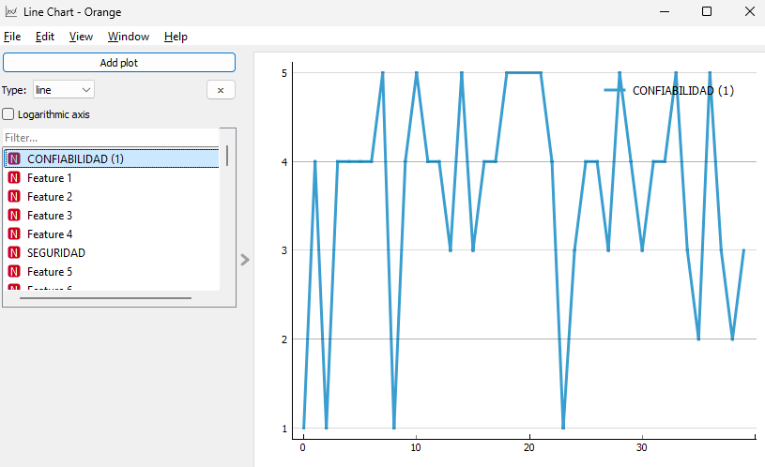

Chart 1. Reliability

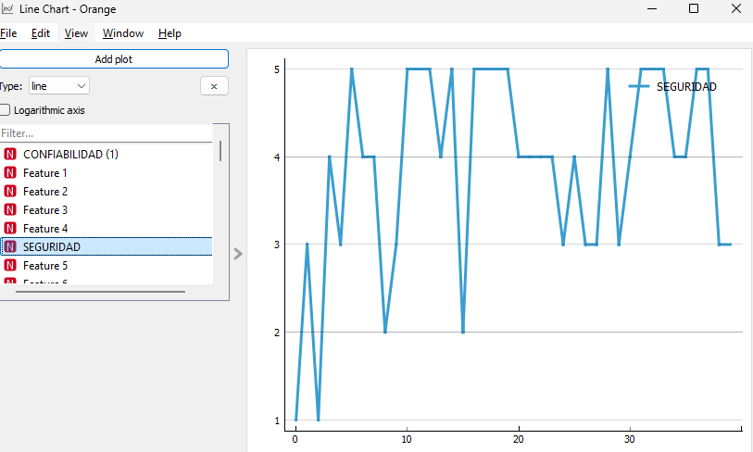

Chart 2. Security

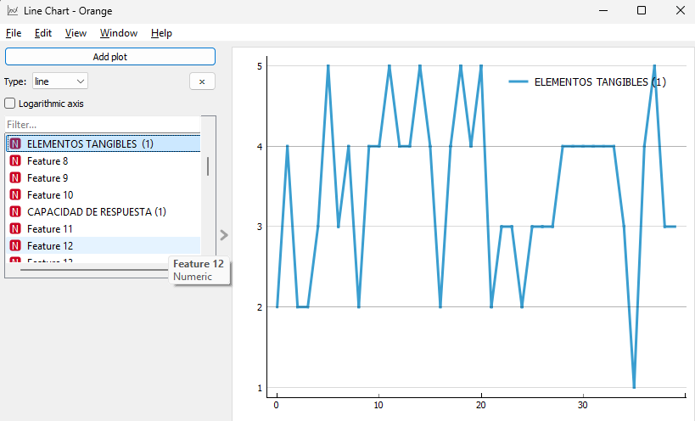

Chart 3. Tangible Elements

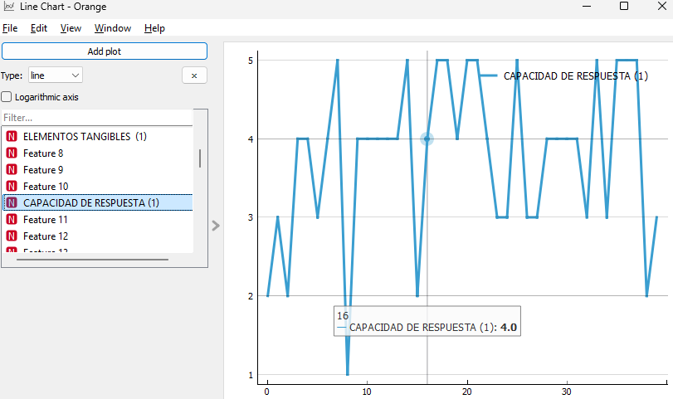

Chart 4. Responsiveness

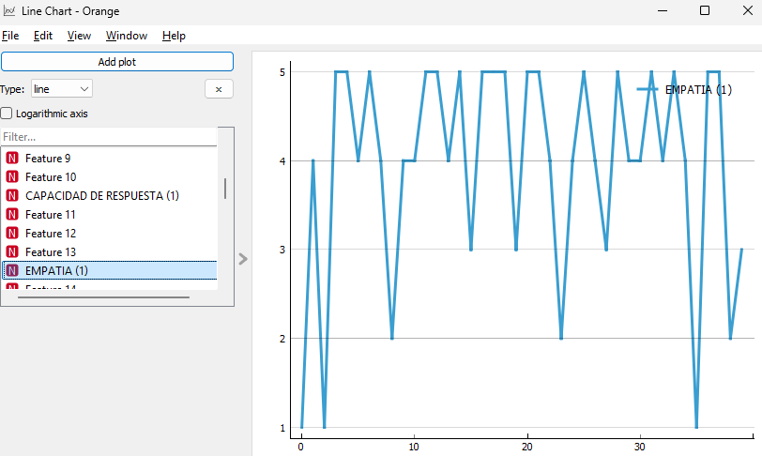

Chart 5. Empathy

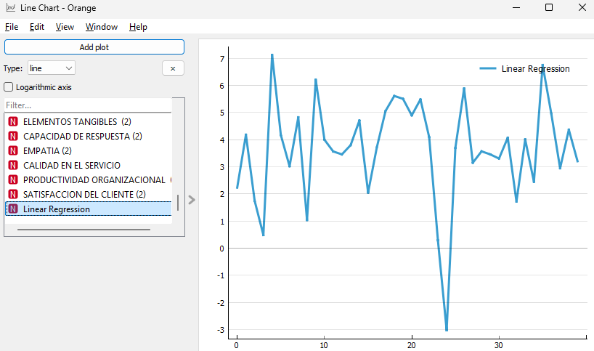

Graph 8. Linear Regression

1. Conclusions

The objective of this research was to evaluate and analyze the degree of influence of quality on the service, through a linear regression, of the interactive program that uses Python programming language and Animaze software, for testing learning styles for children, youth, and adults.

The linear regression model in the figure provides a quantitative approach to analyzing service quality and customer satisfaction. Data trends suggest fluctuations in metrics, which may indicate the need for strategic adjustments within the company. Furthermore, regression analysis helps identify patterns that may be key to improving organizational productivity.

The data suggests that continuous improvement in reliability, security, responsiveness, and empathy is key to optimizing the user experience, increasing satisfaction, and strengthening the usability of the interactive program. Implementing strategies to stabilize perceptions of these factors can contribute to greater system acceptance and effectiveness.

Therefore, it is proposed:

Implement more robust security protocols to protect user information.

Provide efficient technical support to address incidents and build user confidence.

Improve the visual interface with an intuitive and accessible design.

Ensure that graphic and functional resources are of high quality and contribute to the user experience.

References.

[1] AZV &. B. Parasuraman, "A Conceptual Model of Service Quality and its Implications for Future Research.," Journal of Marketing, pp. 41-95, 1985.

[2] R. Schroeder, Operations Management., Mexico: Editorial McGraw-Hill., 1992.

[3] AI & BS Starcic, « ICT-supported learning for inclusion of people with special needs: Review of seven educational technology journals," British Journal Of Educational Technology, pp. 202-230, 2013.

[4] PGGOB-CS &. MBS Lacava, "Using Assistive Technology to Teach Emotion Recognition to Students with Asperger Syndrome.," Remedial and Special Education, vol. 3, pp. 174-191, 2007.

[5] HHWSWCDFBJLCYVSLKS &. WJY Ip, "Enhance emotional and social adaptation skills for children with autism spectrum disorder: A virtual reality enabled approach.," Computers and Education/Computers & Education, vol. 117, pp. 1-15, 2018.

[6] . Grönroos, “A Service Quality Model and Its Marketing Implications,” European Journal of Marketing, vol. 18, no. 4, pp. 36-44, 1984.

[7] S. &. T.M. López, "Measuring Service Quality in the Textile Industry," IEU University Journal, vol. 4, no. 8, pp. 1-32, 2020.

[8] R. &. LJ Pérez, «Evaluation of service quality in air transport using the SERVQUAL model: A study in Sucre, Bolivia. », Journal of Quality in Transport, pp. 45-60, 2017.

[9] FAN &. PL Ganga, "Service Quality Measurement Using the SERVQUAL Model: The Case of the Puerto Montt Guarantee Court"- Chile., Chilean Engineering Journal, pp. 668-681, 2019.

[10] MRBZZ &. LH Jebraeily,). Using SERVQUAL Model to Assess Hospital Information System Service Quality. Hormozgan Medical Journal, vol. 23, pp. 1-6, 2019.