From Debt to Decision: An Engineering Economic Analysis of Kenya’s Fiscal Metrics

Mr. Robin Wachania
Industrial Management Program
University of Central Missouri
Warrensburg, MO, USA.
RXW49200@ucmo.edu
Jeff Ulmer, Ph.D.
Industrial Management Program
University of Central Missouri
Warrensburg, MO, USA.
julmer@ucmo.edu

Abstract— This research paper explores the impact of domestic borrowing as incurred by the Kenyan government on inflation, showing how rising debt levels influence macroeconomic stability. As the Kenyan government relies increasingly on domestic borrowing to finance financial deficits, it is essential to understand the mechanisms through which such debts affect inflationary measures within the country. Domestic debt may contribute to inflation by increasing the money supply through central bank financing, crowding out in the private bank sector segments, and influencing expectations of future price levels. This study shall adopt a systematic approach to analyze these relationships, focusing on identifying feedback loops between governmental growth and money supply, inflation rates, and private sector investments. Through systematic analysis, this research shall understand and contribute to the body of knowledge on the intersection between fiscal policies and inflation dynamics within Kenyan economics.
Keywords—Kenya, Inflation, Finance

Introduction
Like many other developing economies in the Global South, Kenya is facing an ever-growing burden of debt, domestic and external. Domestic debt, in particular, is a key concern as it shapes the country’s macroeconomic landscape. Over the years, the Kenyan government has relied on domestic borrowing to finance its financial deficits, with debt reaching alarming levels. The majority of this debt is audacious debt, which has come under scrutiny as it was not allowed and vetted by the legislative arm of the government, which happens to be the parliament. This reliance on debt, coupled with opulence in government expenditure and laxity in fiscal management, has profound implications for inflation and overall economic stability [1].
In recent months, Kenya’s fiscal policies have sparked widespread debate, which has caused protests surrounding the Finance Bill of 2024. This bill proposed numerous tax hikes and levies aimed at increasing government revenue and addressing rising public debt [2]. However, this bill and its proposals were met with public outcry and protests as many business groups, individuals, and social groups perceived it as government outreach that would reduce disposable income for businesses and individuals. Government critics pointed to the reckless spending and the lack of transparency, alleging that public officials and politicians often misappropriated funds for different government expenditures and projects [2]. This perception of political theft and rampant corruption is essential to understanding Kenya's broader issue of inflation. Excessive spending by the government, especially on non-productive and politically motivated projects, has led to inflation. This causes the government to borrow more to finance its expenditure, which leads to expanding the money supply, often without increased national output. The imbalance between demand and supply of goods and services, driven by excessive economic liquidity, leads to inflation in the country [2].
Furthermore, the political elite has exacerbated inflation when they divert public funds. This deliberate theft of taxpayer money undermines the effectiveness of fiscal policies and projects to stimulate and maintain economic growth [3]. Instead of investing in infrastructure, healthcare, or education to stabilize the economy and improve productivity in the long run, taxpayer money is often routed and diverted into schemes with no economic return, such as the new healthcare coverage known as SHA or Housing projects in remote areas [4]. This results in a gap that is currently widening between government spending and economic output, which is contributing to inflation in the country [3]).
The relationship between government domestic borrowing, inflation, and fiscal management is crucial in this context [3]. The Kenyan government continues borrowing from domestic sources such as banks and bonds, putting more money into circulation. As the borrowing increases, the central bank is pressured to monetize this debt, further increasing the money supply, pushing inflation higher, and the value of money lower. Meanwhile, this has made interest rates unaffordable for the common ‘mwananchi’ (citizen), which has reduced access to credit, increasing struggles to maintain productivity, and contributing to inflation. This research aims to show the connections between these variables, examining how the Kenyan government, its domestic debt, and political corruption contribute to inflation. Through analysis of variables, the study shall explore the economic mechanisms that play a role in debt accumulation, inflation, and government spending. Ultimately, this research shall offer insights and illuminate how domestic debt contributes to inflation, curtailing sustainable growth, and exacerbating economic challenges.

Variable Information
Data Sources - The data used for this research paper was collected from the Central Bank of Kenya, both of which have been cited below [5] [6].
Annual Average Inflation - This is the average inflation rate over the last 12 months, which gives a view of price changes within the Kenyan economy. It is a reflection of long-term inflation trends that minimize the volatility experienced month to month. Commonly used to assess overall economic stability in the long-term purchasing power of the consumers [7].
12-Month Inflation - This is also known as year-on-year inflation and is compared to the consumer price index of a given month to the same month in the previous year. It is a reflection of short-term price changes and is mostly used to track recent inflammatory pressures that affect businesses and consumers more immediately [7].
Government Debt - Government debt is the total amount of money that the government owes both domestically and externally [5]. It is a reflection of the government’s borrowing to fund public services, budget deficits, and infrastructure. High debt levels often affect the credit ratings of nations, interest rates, and the fiscal space of a country.

III. Indicators and Understanding of Selected Variables
In the assessment of the dynamics between inflation in government debt over the period 2022 and early 2025, two key inflationary indicators were analyzed for this essay. Annual average inflation and 12-month inflation covering the periods from January 2020 to February 2025 were used. The annual average inflation reflected the long-term inflation rate of a 12-month period, and for this analysis, there was a fluctuation between 5.29% in January 2020 and 3.98% in February 2025, picking up at 8.78% in May 2023 [5]. Despite the upward trend in government debts, the correlation between the coefficients and the annual average inflation in government debt was weakly positive. While there was a significant relationship between the two variables, the strength of the correlation is minimal, suggesting that increases in government deaths are not strongly associated with changes in annual average inflation [6]. This implies that there are other factors at play, such as fiscal policy decisions, external borrowing patterns, foreign exchange volatilities, or government interference in the market, that play more dominant roles in driving public debt growth [8].
The 12-month inflation rate measures short-term inflation by comparing the consumer price index of a given month with that of the same month in the previous year. Unlike annual average inflation, this mission is more volatile, ranging from a low of 2.72% in October 2024 to a high of 9.59% in October 2022. The correlation between 12-month inflation and government debt was weakly negative; its statistical significance was high. This inverse relationship, even though we reflect that there could be inflation surges, well, there is reduced borrowing by the government. It could also suggest that rising inflation prompts debt servicing or erodes the value of the outstanding debts [1].
In this study, government debt was treated as the independent variable. The government debt doubled over the study period from three trillion Kenya shillings to six trillion Kenya shillings in February 2025 [5]. The inflation indicators show a minimal correlation with this debt accumulation over the last five years. This could suggest the weakening of the local Kenyan currency, which increases the cost of foreign-denominated debt. Additionally, it shows that while inflation is an essential measure of the macroeconomy's status, it does not influence government debts, at least for the period observed.

Data Analysis
The data used in this study were compiled from the official Central Bank of Kenya data sets, which are cited below. Key economic variables such as the annual average inflation, 12-month inflation, and government debt were analyzed using Microsoft Excel. Using Excel, the relationships between inflation indicators and government debt were examined through correlational analysis. The results were as follows in Figures 1 and 2.

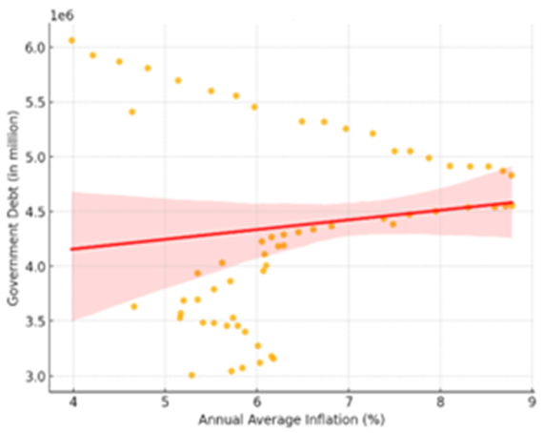
Figure 1. Annual Average Inflation versus Government Debt

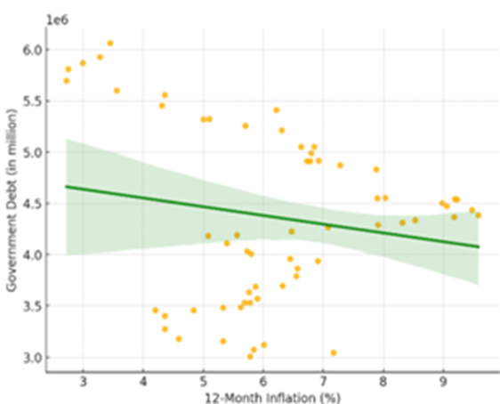
Figure 2. 12-Month Inflation versus Government Debt

For this paper, a correlational study was also conducted between government borrowing and lending rates from local Kenyan banks, which revealed a strong positive correlation of r=0.86935. This finding implies a direct relationship between public sector domestic borrowing and the cost of credit to private individuals and businesses. When the Kenyan government borrows heavily from local banks, it competes with the private sector for capital, pushing lending rates up and crowding out private investment. This link means that investors must closely watch domestic borrowing trends, as it could make financing for private projects more expensive and slow economic growth (see Figure 3).

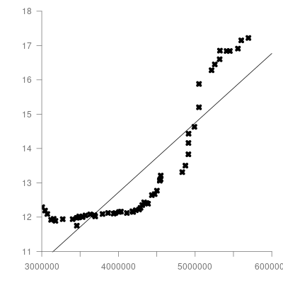
Figure 3. Government Borrowing and Lending

Conclusions and Recommendations for Investors
Analyzing inflation trends in government domestic debt reveals important and subtle signals for current and future investors. While the annual average and 12-month inflation show statistically weak correlations with government debt levels, this suggests that inflation alone is not a primary driver for debt accumulation. However, it is a player in shaping Kenya's fiscal policies, interest rates, and general investment climate. For investors, this data is critical for decision-making. Inflation has been shown to erode real returns, especially for fixed-income investments [9].
Additionally, the increase in government domestic debts could imply future tax policy shifts, austerity measures, and adjustments in public sector investments, which affect business environments and investor returns. Finally, inflation rates indicate fiscal tightening and reduced customer demand, especially for investors in FCMG products. Investors should look out for the following metrics for deeper decision-making. The metrics, such as inflation rates, government debt to GDP ratio, interest rates, exchange rate stability, primary budget balance, and sovereign credit ratings, affect external and internal investors [9].
Inflation rates help the investor understand purchasing power and future interest rate trends, while the government debt-to-GDP ratio indicates the country’s ability to manage and repay its debts. Additionally, the central bank's interest rates directly influence borrowing costs and investment returns, while exchange rate instability could trigger currency volatility, affecting returns on foreign investments.
Finally, the primary budget balance is a sign of fiscal discipline, which could predict future borrowing needs, while sovereign credit ratings reflect the country’s creditworthiness and investment risk, indicating the environment for investing. Investors should diversify geographically and by asset class, especially for growing economies like Kenya, to hedge against local economic risks such as debt crises and inflation spikes. Additionally, they should monitor macroeconomic policies closely, especially those that affect fiscal policy updates such as taxation and tariffs [9]. Lastly, investors should use the government's inflation-protected instruments, such as treasury bonds, when inflation is high.

References
[1] Aimol, A. U., & Odhiambo, N. M. (2020). External debt, domestic debt and economic growth: The case of Nigeria. Advances in Economics and Business, 8(2), 85-94. https://doi.org/10.13189/aeb.2020.080202
[2] Omer, N. (2024). Thursday briefing: How one controversial bill has Kenya on the brink of disorder. the Guardian. https://www.theguardian.com/world/article/2024/jul/18/first-edition-kenya-public-protests-finance-bill
[3] Sylla, N. S. (2023). Imperialism and Global South's debt: Insights from modern monetary theory, ecological economics, and dependency theory. Research in Political Economy, 193-222. https://doi.org/10.1108/s0161-723020230000038008
[4] Thiongó, J. (2025). SHIF: Private hospitals warn system could collapse in 12 months. The Standard. https://www.standardmedia.co.ke/national/article/2001513157/shif-private-hospitals-warn-system-could-collapse-in-12-months
[5] Central Bank of Kenya. (2024). Government finance statistics. CBK | Central Bank of Kenya. https://www.centralbank.go.ke/statistics/government-finance-statistics/
[6] Central Bank of Kenya. (2024). Inflation rates. CBK | Central Bank of Kenya. https://www.centralbank.go.ke/inflation-rates/
[7] Kenya National Bureau of Statistics. (2024). 1 | P a g e Understanding Kenya's Consumer Price Index (CPI): A Crucial Economic Indicator. Kenya National Bureau of Statistics - Kenya's Top Data Site. https://www.knbs.or.ke/wp-content/uploads/2024/06/Kenya-Consumer-Price-Indices-Article-on-CPI.pdf
[8] Aimola, A. U., & Odhiambo, N. M. (2020). Public debt and inflation: A review of international literature. Folia Oeconomica Stetinensia, 20(1), 9-24. https://doi.org/10.2478/foli-2020-0001
[9] Mandeya, S. M., & Ho, S. (2021). Inflation, inflation uncertainty and the economic growth nexus: An impact study of South Africa. MethodsX, 8, 101501. https://doi.org/10.1016/j.mex.2021.101501

